Query Orders By Location Type And Location

Overview

Current processing
- These are the internal methods for OMT Help Desk.

New requirement
- Change the getOrdersByLocationType() method’s signature by passing an array of LocationType, TransactionId and RequestUserId.
- Change the getOrdersByLocation() method’s signatures by passing the location, transactionId and requestUserId.
- The return struct needs to redefine based on GUI request.
- Change both queries to asynchronous call. The orders will be published on the OrderRouting event channel.

Implementation

Change the method’s signature on OrderHandlingService interface.
public ServerResponseStruct [] getOrdersByLocationType(short[] locatonTypes, String transactionId, String requestUserId)
throws SystemException, CommunicationException, AuthorizationException,

struct ServerResponseStruct
{
String serverId;
Short errorCode;
String description;
};

public ServerResponseStruct [] getOrdersByLocation (String locaton, String transactionId, String requestUserId)
throws SystemException, CommunicationException, AuthorizationException,

Implement OrderHandlingServiceRoutingProxy.getOrdersByLocationType
- Validate the array of location type parameter and throw DataValidationException on any undefined location type.
- Make federate calls to all the OHS that export the OrderHandlingService.
- Build the returned array of ServerResponseStruct, which contains the serverId, error code and description associated with each OHS.
- Publish the order summary struct on the OrderRouting event channel.

The following is the sequence diagram for the query:
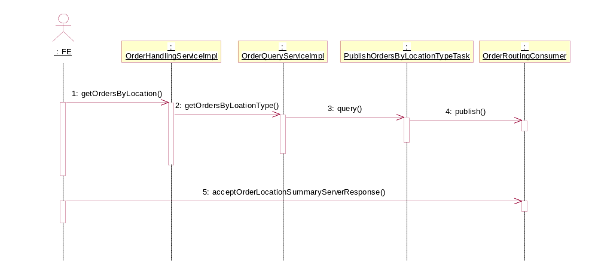

Implement OrderQueryService.getOrdersByLocation
- Make federate calls to all the OHSs that export the OrderHandlingService.
- Build the returned array ServerResponseStruct that contains the status of each OHS with the server id, error code and description .

The following is the sequence diagram of query orders by a location:

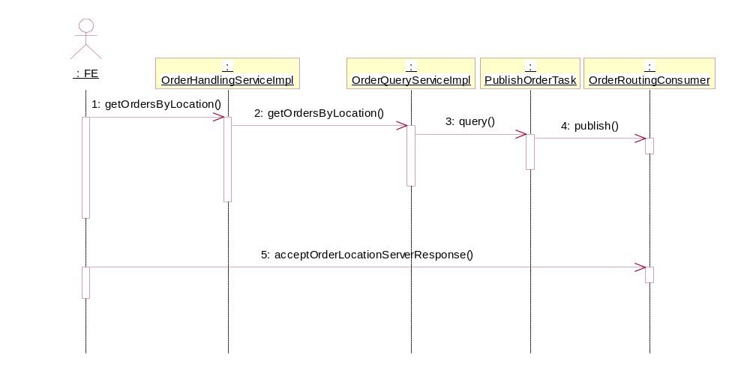

Implement PublishOrderTask class
- The constructor of PublishOrderTask starts a thread pool with minimum size of 1 and maximum size of 3.
- The method query puts the getOrdersByLocation in the queue for the thread pool to process the request by creating an Runnable object which will query the OrderCacheManager for the orders by location and publishes the orders on the OrderRouting event channel.

Implement PublishOrdersByLocationTypeTask class
- The constructor of PublishOrdersByLocationTypeTask starts a thread pool with minimum size of 1 and maximum size of 3.

- The method query() puts the getOrdersByLocationType request in the queue for the thread pool to process the request by creating an Runnable object which will query the OrderCacheManager for the orders by location and publishes the order summary on the OrderRouting event channel.

Scripts
- None

Database
- None

SetContext
- None

XML/DTD
- .

Homes/Services

ImplPlan
- .

PerformanceTestingProcedure
- .

TestingProcedure
- .

OperatorProcedure
- .

Fallback/Failover
- .

